**Classification de Panneaux de Signalisation Routière**

1. **Data exploration**

**Training dataset**

* Number of images: 39209
* Number of classes: 43
* Maximum Width in Pixel: 243
* Maximum Height in Pixel: 225

**Testing dataset**

* Number of images: 39209
* Number of classes: 43

**Have a look on random image of each class**

**Define the label dictionary**

Based on the clear image of ./Meta folder, we can find out the class name corresponding to the classID as follows.

classes = { 0: 'Speed limit (20km/h)', 1: 'Speed limit (30km/h)', 2: 'Speed limit (50km/h)', 3: 'Speed limit (60km/h)', 4: 'Speed limit (70km/h)', 5: 'Speed limit (80km/h)', 6: 'End of speed limit (80km/h)', 7: 'Speed limit (100km/h)', 8: 'Speed limit (120km/h)', 9: 'No passing', 10: 'No passing veh over 3.5 tons', 11: 'Right-of-way at intersection', 12: 'Priority road', 13: 'Yield', 14: 'Stop', 15: 'No vehicles', 16: 'Veh > 3.5 tons prohibited', 17: 'No entry', 18: 'General caution', 19: 'Dangerous curve left', 20: 'Dangerous curve right', 21: 'Double curve', 22: 'Bumpy road', 23: 'Slippery road',  24: 'Road narrows on the right', 25: 'Road work',  26: 'Traffic signals', 27: 'Pedestrians',  28: 'Children crossing', 29: 'Bicycles crossing', 30: 'Beware of ice/snow', 31: 'Wild animals crossing', 32: 'End speed + passing limits', 33: 'Turn right ahead', 34: 'Turn left ahead', 35: 'Ahead only', 36: 'Go straight or right', 37: 'Go straight or left', 38: 'Keep right', 39: 'Keep left', 40: 'Roundabout mandatory', 41: 'End of no passing', 42: 'End no passing veh > 3.5 tons' }

**Showing the number of Training Images for each ClassID.**

The number of images for each classID is not balanced. This can cause model bias, when it is more likely to learn features from the dominant classID, and as a result make more correct predictions for dominant classes than the minority classes.

**Showing distributions in Image sizes, including Width and Height**

We see that most of the images have less than 50 pixel in width and height.

1. Data Loading

class GTSRBDataset(Dataset):

    def __init__(self, csv_file, root_dir, transform=None):

        self.data = pd.read_csv(csv_file)

        self.root_dir = root_dir

        self.transform = transform

    def __len__(self):

        return len(self.data)

    def __getitem__(self, idx):

        img_path = os.path.join(self.root_dir, self.data.iloc[idx, 7]) *# Path is in column 7*

        image = Image.open(img_path).convert('RGB')

        label = self.data.iloc[idx, 6] *# ClassId is in column 6*

        if self.transform:

            image = self.transform(image)

        return image, label

1. Data processing and preparation

*# Define data augmentation and normalization transformations*

transform = transforms.Compose([

    transforms.Resize(image_size),

    transforms.ToTensor(),

    transforms.Normalize(mean=[0.485, 0.456, 0.406], std=[0.229, 0.224, 0.225])

])

*# Load datasets*

train_dataset = GTSRBDataset('./data/Train.csv', './data', transform=transform)

test_dataset = GTSRBDataset('./data/Test.csv', './data', transform=transform)

*# Split train dataset into train and validation*

train_size = int(0.8 * len(train_dataset))

val_size = len(train_dataset) - train_size

train_data, val_data = random_split(train_dataset, [train_size, val_size])

*# Create data loaders*

train_loader = DataLoader(train_data, batch_size=batch_size, shuffle=True)

val_loader = DataLoader(val_data, batch_size=batch_size, shuffle=False)

test_loader = DataLoader(test_dataset, batch_size=batch_size, shuffle=False)

1. Building base CNN model

Hyperparameter configuration

image_size = (32, 32)

batch_size = 16

num_epochs = 10

validation_split = 0.2

lr=0.001

1. Experimentation to improve model performance

More complex CNN

Data Augmentation

During training we apply several transformation techniques on the fly to increase the variety of training image, that help model more robust and against model overfitting.

transform = transforms.Compose([

    transforms.Resize(image_size),

    transforms.RandomHorizontalFlip(),

    transforms.RandomRotation(10),

    transforms.ColorJitter(brightness=0.2, contrast=0.2, saturation=0.2, hue=0.2),

    transforms.ToTensor(),

    transforms.Normalize(mean=[0.485, 0.456, 0.406], std=[0.229, 0.224, 0.225])

])

We show here several examples of image after applying the data augmentation techniques.

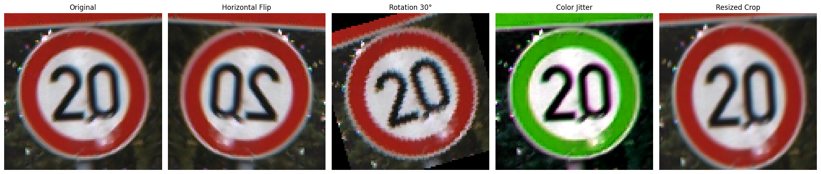

There are several options we can experiment with

|  |  |  |
| --- | --- | --- |
| **Experiments** | **Configuration** | **Performance (F1)** |
| Experiment 1 | Base model: 3 Conv layers, batch=16, epoch=10 | 0.94 |
| Experiment 2 | Experiment 1 with more complex model: 5 Conv layers with normalization and dropout | 0.96 |
| Experiment 3 | Experiment 2 with batch size 32 | 0.96 |
| Experiment 4 | Experiment 3 with Data augmentation | 0.94 |

The training performance is logged like this

1. Performance analysis

Showing the accuracy and loss log of training process

The confusion matrix is then calculated.

Print also the classification report

With the best model, we can plot several predictions. The correct predictions in blue and incorrect predictions in red.

1. CNN visualization

We can also show the activation layer of Conv layers in CNN model like this

1. Transfer learning with VGG

*# Define transfer learning model*

class TransferLearningVGG(nn.Module):

    def __init__(self, num_classes=43):

        super(TransferLearningVGG, self).__init__()

*# Load the pre-trained VGG model*

        self.vgg = models.vgg16_bn(pretrained=True)

*# Freeze the pre-trained layers*

        for param in self.vgg.parameters():

            param.requires_grad = False

*# Modify the classifier to match the number of classes*

        self.vgg.classifier[6] = nn.Linear(4096, num_classes)

    def forward(self, x):

        x = self.vgg(x)

        return F.log_softmax(x, dim=1)

As the expriments are only set for 10 epoche, we see that the VGG model using transfer learning with pretrained VGG weight converge lower than the above small CNN models. That may be because that the VGG take input size as (224x224), while our training images are as small as around (50 x 50). The resize process cause the quality of image worse, therefore the model take more time to converge.